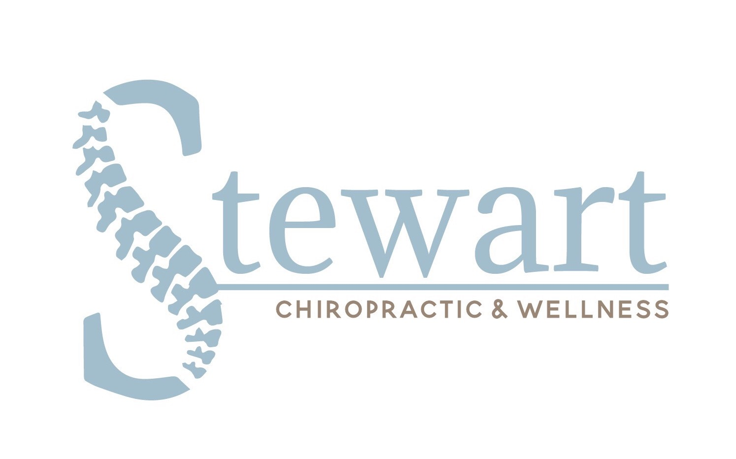
Dr. Nicole Stewart
Chiropractic Physician

220 W Brandon Blvd, St 202• Brandon, FL 33511
(813) 320-8548 • www.drnicolestewart.com

CONSENT FOR TREATMENT OF A MINOR

I hereby request and authorize Dr. Nicole Stewart to perform diagnostic tests and render Chiropractic adjustments and other treatment to my minor child:

___________________________________________________________________ _____/____/______
Name of Child Date of Birth

This authorization also extends to other licensed Chiropractic Physicians and assistants acting under her responsibility and supervision.

As of this date, I have the legal right to select and authorize health care services for the minor child named above.

(If applicable) Under the terms and conditions of my dissolution of marriage or separation, I have the legal right to select and authorize this care for my minor child without consent of my spouse/former spouse. If my authority to authorize such care is revoked or modified, I will immediately notify this office.

I have read, or have had read to me, the above Consent. I have also had an opportunity to ask questions about its contents, and by signing below on behalf of my minor child, acknowledge my understanding of its contents.

________________________________________________ _________________________
Signature of Parent or Guardian Date

_________________________________________________
Printed Name

_________________________________________________
Relationship to Child

